

Department of Electronics and Computers
Study programme: Applied Electronics

Verification Project
Decimal-to-Gray Code Converter

Table of Contents
1 The digital design of the circuit 3
1.1 Block Diagram 3
1.2 Description of the general functionality of the DUT (Device Under Test) 3
1.3 DUT Interfaces 4
1.4 List of DUT Functionalities 6
1.5 Schematic Diagram 6
1.6 Waveforms 9
1.7 Register Table 9
2 Digital Circuit Verification 11
2.1 Verification Environment Architecture 11
2.1.1 SPI Interface Driver 11
2.1.2 APB Driver 11
2.1.3 Scoreboard / Reference Model 11
2.1.4 Monitor APB 12
2.1.5 SPI Interface Monitor 12
2.1.6 APB Interface Transaction 12
2.1.7 SPI Interface Transaction 13
2.1.8 SPI Interface Agent 13
2.1.9 APB Interface Agent 13
2.1.10 SPI Interface Coverage Collector 13
2.1.11 Scoreboard / Reference Model Coverage Collector 13
2.1.12 Coverage Collector for APB Interface 14
2.1.13 APB Sequences 14
2.2 Verification Checklist 14
2.1 Assertion Enable Mechanism 15
2.3 Functional Coverage Elements 16
2.4 Verification Scenarios and Tests 17
2.5 Results 19

The digital design of the circuit
Block Diagram
General Functionality Description of the DUT (Device Under Test)
DUT Interfaces
List of DUT Functionalities
Schematic Diagram
Waveforms
Register Table

Block Diagram

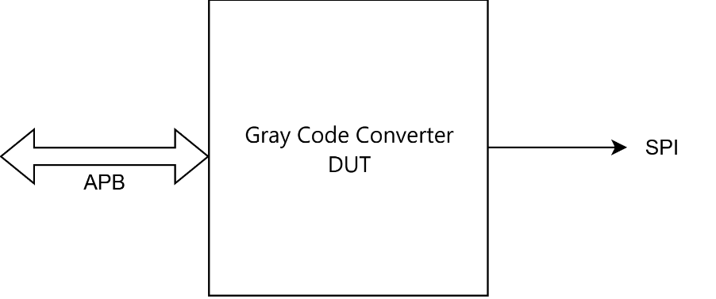

Figure 1. Block diagram of the converter

Description of the general functionality of the DUT (Device Under Test)
The DUT converts an 8-bit binary number to Gray code. The input value (0–255) is received via the APB slave interface and stored in the OPERAND register. The Gray code conversion is performed using the formula: gray = binary XOR (binary >> 1). The result is transmitted through the SPI master interface. At the input, we will enter a number transmitted through the APB interface, the DUT will contain the logic through which the respective number will be converted to Gray code using an XOR between the most significant bit and the bit shifted to the right, and at the output we will display the converted number through the SPI interface on 8 bits. Since the output will be on 8 bits, we will need to choose a number between 0 and 255, which represents the maximum number written on 8 bits. Since the input is an 8-bit value (0–255) and Gray code conversion preserves the bit width, no overflow is possible. The PSLVERR signal is asserted when: (1) accessing an invalid/undefined address, or (2) attempting to write to the read-only RESULT register (address 0x02). Both the APB and SPI protocols will operate on the same clock.

DUT Interfaces

Table 1. System signals generated in the testbench
General Signals
Signal Name | I/O | Size | Description
clk | I | 1 | Clock signal
reset | I | 1 | Asynchronous reset, active low

Table 2. APB Interface
APB Interface
Signal Name | Number of bits | Direction | Description
PCLK | 1 | Input | Clock signal
PRESET | 1 | Input | Reset signal, active LOW
PADDR | ADDR_WIDTH | Output | Address signal, up to 32 bits
PSELx | 1 | Output | Used for slave selection
PENABLE | 1 | Output | Output Indicates the second  and subsequent transfer cycles
PWRITE | 1 | Output | Write access
PWDATA | DATA_WIDTH | Output | Write data bus, when PWRITE is HIGH
PREADY | 1 | Input | Slave can accept data and address transfers
PRDATA | DATA_WIDTH | Input | Read data bus, when PWRITE is LOW
PSLVERR | 1 | Input | Transfer errors

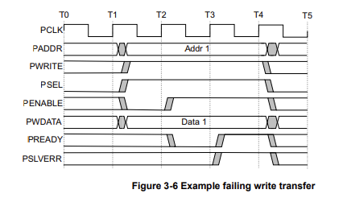
Figure 2. APB protocol with write transfer fail
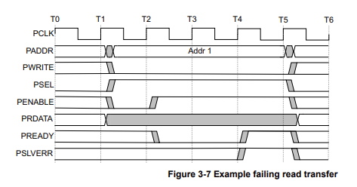
Figure 3. APB protocol with read transfer fail

Table 3. Result display interface signals
SPI Result Display Interface
Signal Name | Number of bits | Direction | Description
SCLK | 1 | Output | SPI clock signal
MOSI | 1 | Output | Data line for transmitting the converted number
MISO | 1 | Input | Data line for reception (not required for TX only)
CS | 1 | Output | Peripheral select (chip select), active on 0

List of DUT Functionalities

- Reception of the input number, and storing it in a register
- Receiving an integer (base 10 with values between 0-255) through the APB interface.
- Conversion to Gray code.
- Transmitting the result through SPI….reg_config bit 0 set to 1.
- Sending the converted number through the SPI interface, using 8-bit packets.
- Notifying the user through an error signal transmitted on APB if an incorrect address was selected.
- Providing a reset signal to return to the initial state.
- Communication on the APB and SPI interfaces
- Compliance with APB communication protocols for input/output and SPI for output.
- It is mandatory to have at least one clock cycle between APB transactions
- Data on MOSI is transmitted on the rising edge of the SCLK signal after the reg_result register has reached 0.

Schematic Diagram
At the input, we will receive a number in base 10, loaded into the OPERAND1 register. There, we will have the APB interface through which we will transmit the number to the DUT. The DUT, through its logic, has the role of transforming the number specified at the input and transmitted through the APB protocol into a binary number, then that number will be encoded in Gray code. The number we want to encode will be written on pwdata, bit by bit, an APB-specific signal, then we will obtain the Gray code through an EXCLUSIVE OR (XOR) between the current bit and the bit shifted to the right. The obtained code will be transmitted at the output through the SPI protocol, subsequently stored in the RESULT register. Loading the result into the RESULT register will be done starting with the most significant bit. Transmitting the result at the output will be done through the SPI protocol, bit by bit, with the help of a counter that will decrement each time it transmits a bit. When it has reached 0, the control register will set the bit corresponding to the completion of the transmission.
Before performing the encoding, we must verify that the correct address was accessed for writing data. If this was not done, an error message will appear. If the correct address was written, we proceed with the encoding.

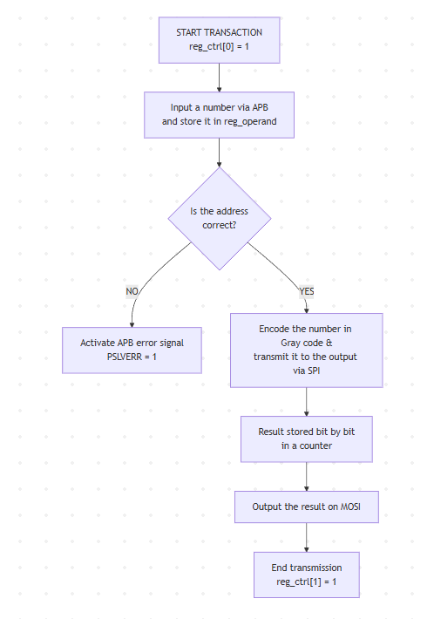
Figure 4: Logical schematic of the DUT
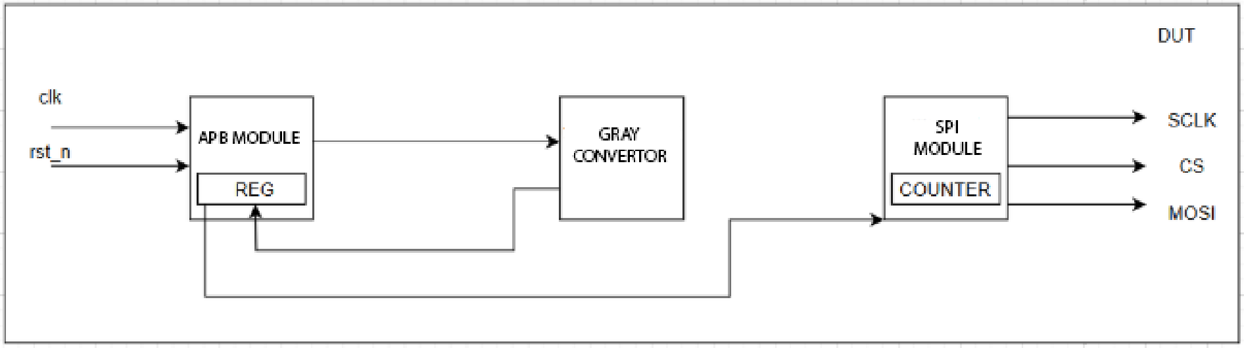
Figure 5: Block diagram of the DUT

Issues encountered:
- Data transmission on SPI cannot be done with the same clock through which we receive data on APB. According to the SPI protocol, SCLK operates only when CS is 0, meaning that is when transmission will begin. Thus, the 2 clocks will not synchronize. The CLK signal will be different from SCLK.
- The CS signal was not synchronizing with MOSI. This is very important because in the SPI protocol, to transmit data on MOSI, CS must be at 0. In experiments, MOSI appeared first, then CS. Solution: Shifting the CS signal by one clock cycle to the left (old_cs).

Waveforms
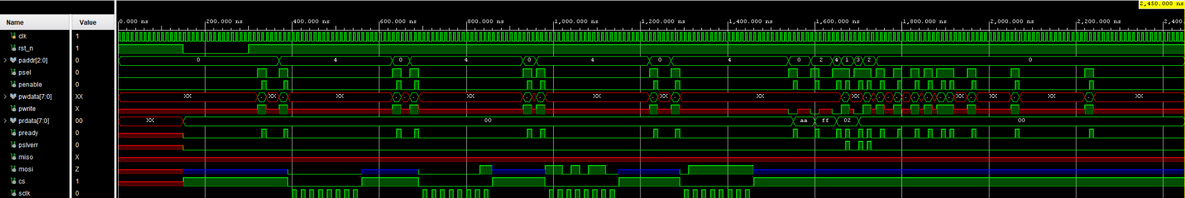
Figure 7: Waveforms from the DUT

Register Table
A table will be created containing the register names, the addresses at which they can be accessed, as well as their descriptions.
Table 4. Registers accessible by the DUT
Register Name | Access Address | Register Structure | Register  Field Description | Register Access Type
OPERAND | 0x00 | 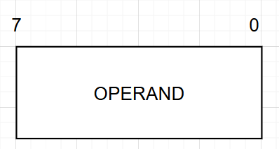 | Operand value (in base 10) | write/ read
RESULT | 0x02 | 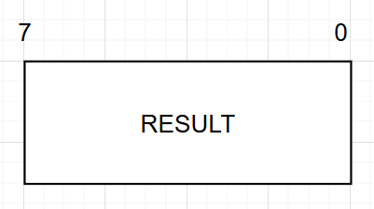 | Result value (in Gray Code) | read
CTRL | 0x04 | 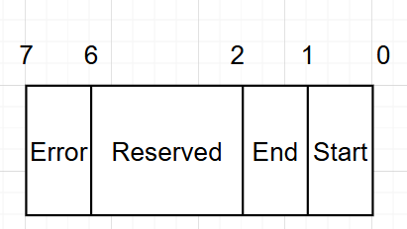 | -0 START Write 1 to begin SPI transmission. Auto-resets to 0 after one clock cycle (pulse behavior).  -1 END Set by hardware when the SPI transmission completes successfully (all 8 bits transmitted). Cleared when a new START is written.  - 6-2 Reserved bits (set to 0).  - 7 Set by hardware when an SPI transmission was interrupted before all 8 bits were sent (CS deasserted prematurely). | write/ read

Parameters used:
- Parameter NO_OF_SPI_BITS = 8 => bits used for transmission in the SPI case

Digital Circuit Verification
Verification Environment Architecture
Verification Checklist
Functional Coverage Elements
Verification Scenarios
Tests Results

Verification Environment Architecture

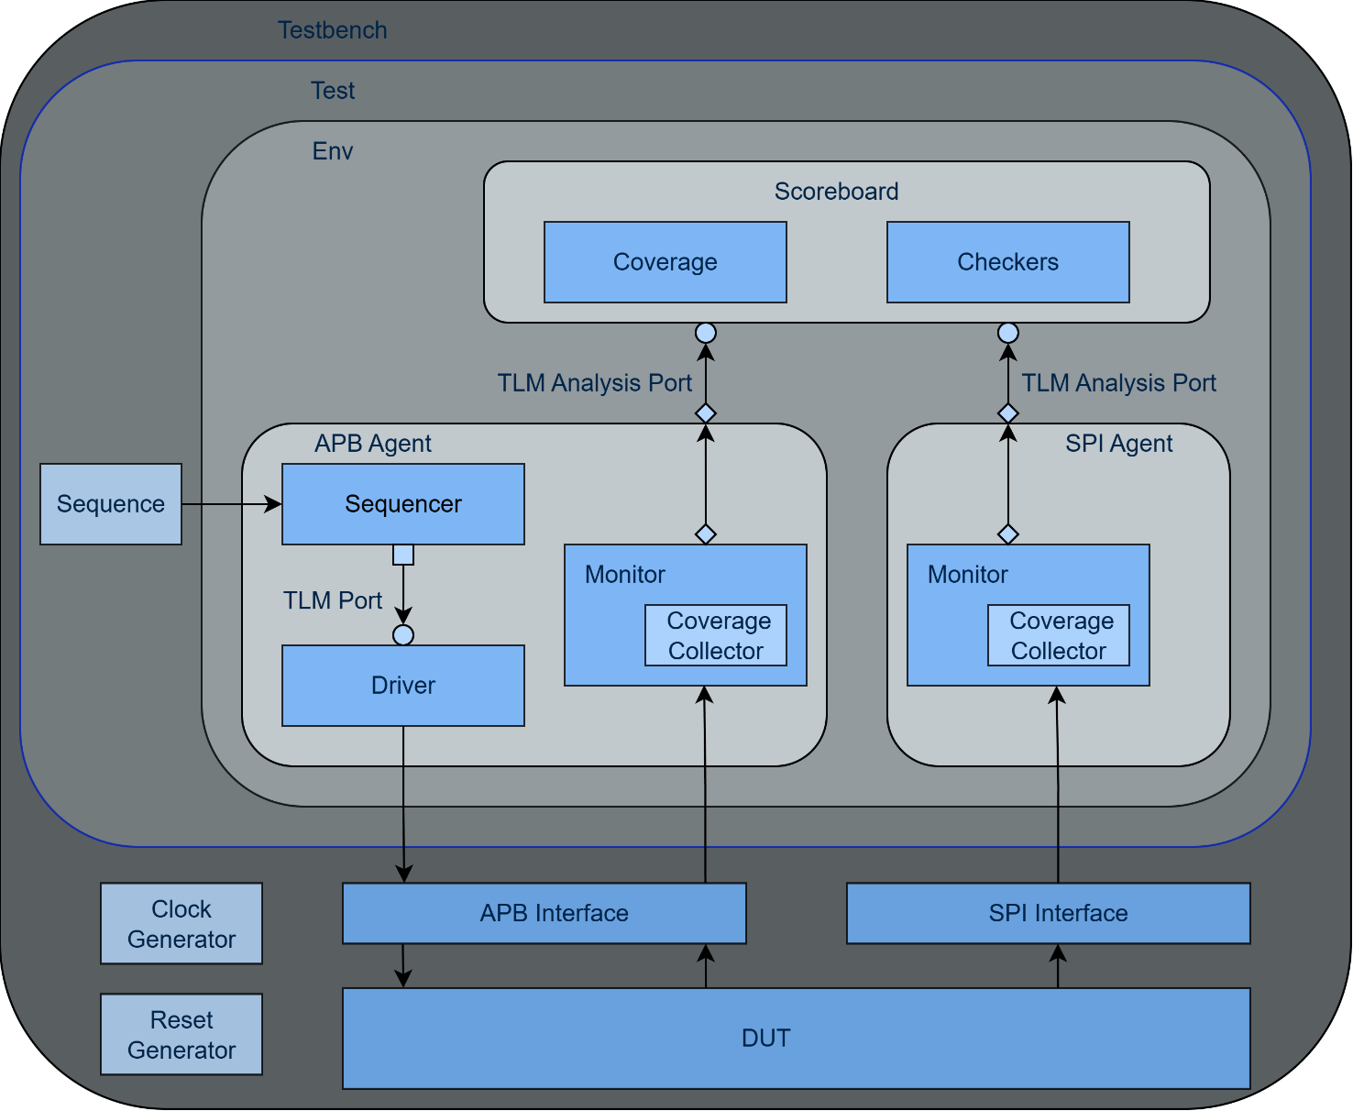
Figure 8. Overview of the components necessary for sending stimuli to the DUT via the APB interface

SPI Interface Driver
The SPI interface is an output-direction port of the DUT which is used to send the Gray code conversion result bit by bit on the MOSI line (the MISO line is declared in the interface but it is not used). This interface does not have a driver or sequencer as the data is generated by the DUT and consumed externally. The only way to provide stimulus for the conversion (writing the OPERAND register and asserting the START bit in CTRL) is via the APB Driver. SPI output is viewed using SPI Monitor.

APB Driver
The APB driver interacts directly with the DUT, sending transactions generated at an abstract level through the interface specified by the APB_DRIV_IF macro. These transactions follow the APB communication protocol and can include read or write operations to the DUT registers.
When the psel signal is active, the driver transmits the address, the transaction type (pwrite) and, in the case of a write, the pwdata value taken from the item. For read transactions, the value is taken from the prdata signal. According to the protocol specifications, the penable signal is asserted one clock cycle after psel.

Scoreboard / Reference Model
The scoreboard operates as a functional verification component for a digital module that performs the conversion of an integer to Gray code, using the APB and SPI interfaces. Its role is to verify the correctness of the DUT's operation by comparing the values received from SPI with the values calculated internally. Communication with the DUT is done through three registers accessed via APB:
- OPERAND (address 0x00): register that contains the input value (in base 10) for conversion. It can be read and written.
- RESULT (address 0x02): register that contains the result of the Gray code conversion. It is read-only.
- CTRL (address 0x04): controls the operation state. Writing 1 to the START bit (bit 0) triggers the conversion. The END bit (bit 1) indicates the completion of the operation. Bits 6–2 are reserved, and bit 7 (INVALID) indicates whether the last conversion was invalid.
The scoreboard receives transactions from APB, which it analyzes based on address. In the case of a write transaction, the values are stored in the corresponding registers and sampled in the functional coverage group. In the case of reads, they are compared with the already stored values to verify consistency. Subsequently, the operand value is converted locally to binary, then to Gray code. Transactions coming from SPI are then compared with the expected value (calculated by the scoreboard). If there are discrepancies, an error message is generated. Additionally, an inverse decoding from Gray to binary is performed to verify that the process is complete and correct.

Monitor APB

The APB monitor is a passive component that captures bus signals through the virtual interface and reconstructs APB transactions. It operates on the negative edge of PCLK to ensure stable signal sampling (the driver drives signals on the positive edge). For each transaction, the monitor:
- Counts the number of idle clock cycles (PSEL=0) between transactions, stored as the delay field
- Detects the SETUP phase when PSEL becomes 1
- Waits for the ACCESS phase completion (PENABLE=1 and PREADY=1)
- Captures address, write direction, data (PWDATA for writes, PRDATA for reads), and PSLVERR
- Publishes the transaction to the scoreboard via a TLM analysis port
- Triggers sampling of the APB coverage collector

SPI Interface Monitor
The SPI monitor is a passive component that captures the CS, SCLK and MOSI signals from the DUT. It detects the valid transmitted sequences and reconstructs the data packet. It sends the transaction to the scoreboard for validation. It operates only when CS is active (logic 0).

APB Interface Transaction
A transaction class in UVM represents a flexible and modular mechanism used to model, store and manipulate data and signals that circulate between the verification environment components. It facilitates communication between the generator, driver, monitor and other testbench components, allowing abstract management of transactions, as well as applying constraints and generating random values in accordance with the tested protocol.

SPI Interface Transaction
The SPI transaction defines the structure of the transmitted data: the value converted to Gray code, sent bit by bit. It contains a single 8-bit field (data) representing the reconstructed Gray code value from the MOSI line.

SPI Interface Agent
The SPI agent is a passive agent that contains only a monitor. Since the SPI interface is an output of the DUT, no driver or sequencer is needed. The monitor captures the data transmitted on the MOSI line and sends it to the scoreboard for verification.

APB Interface Agent
An agent encapsulates the Sequencer, Driver and Monitor into a single entity, connecting the components using the virtual interface.

SPI Interface Coverage Collector
The SPI coverage collector monitors the range of Gray code values transmitted on the MOSI line. The covergroup stari_spi_cg contains a single coverpoint on the transmitted data with 4 bins:
- min_data: value 0
- random_data: values 1–154
- random_data_1: values 155–254
- max_data: value 255
SPI protocol compliance (CS activation, SCLK behavior) is verified separately through assertions defined in the SPI interface module, not through the coverage collector.

Scoreboard / Reference Model Coverage Collector
The coverage collector in the scoreboard strictly monitors the values written on the APB bus, through the registers_cg group, sampled at each WRITE transaction. This guarantees that all extremes (0 and 255), the intermediate zones of the operand, and the status bits (INVALID, END) are exercised at least once. The Binary → Gray conversion emitted on SPI is not covered by a separate covergroup; its correctness is validated functionally by the scoreboard through direct comparison between the actual packet and the reference model prediction (verify_data_match). If the value does not match, a uvm_error is reported, otherwise the test is marked “PASS”.

2.1.12 Coverage Collector for APB Interface
The APB coverage collector (coverage_apb) is instantiated inside the APB monitor and samples transaction data after each detected APB transfer. It contains the covergroup stari_apb_cg with 6 coverpoints: address (addr_cp), inter-transaction delay (delay_cp), error status (perror_cp), write direction (pwrite_cp), data value (data_cp), and a cross coverage of address x direction (cross_addr_cp_pwrite_cp). This collector achieves 100% coverage with the test_coverage_100 test.

2.1.13 APB Sequences
The APB sequences generate stimulus for the APB driver. Each sequence creates one or more constrained-random transactions that the driver converts into APB bus cycles. The following sequences are implemented:

Sequence | Description
apb_seq_write_addr0 | Writes a random data value to the OPERAND register (address 0x0). Delay constrained to 0–3 cycles.
apb_seq_write_addr0_fixed_data | Writes a specific (user-defined) data value to the OPERAND register. Used for targeted testing of known operands.
apb_seq_write_addr4 | Writes the START command (0x01) to the CONTROL register (address 0x4) to initiate SPI transmission.
apb_seq_read | Reads from a specified address. Used to verify register contents after operations.
apb_seq_generic | Fully configurable sequence: allows specifying arbitrary address, write/read direction, data value, and inter-transaction delay. Used for targeted testing of invalid addresses, error conditions, and specific delay bins for coverage.
apb_sequence | General-purpose random sequence that generates 10–15 transactions with random addresses (0–4), random write/read direction, and delays constrained to 0–3 cycles.

Verification Checklist

2.1 Assertion Enable Mechanism

All APB assertions use a disable iff guard that keeps them inactive until the reset signal (rst_n) has completed a full LOW-to-HIGH transition. This prevents false assertion failures during the initial simulation phase when DUT output signals (PREADY, PSLVERR) may be in unknown (X) states.

The mechanism uses two internal flags:
- rst_n_seen_low — set to 1 when rst_n goes LOW (negedge detected)
- rst_n_was_applied — set to 1 when rst_n returns HIGH after having been LOW
Assertions are only active when rst_n_was_applied == 1, i.e., the DUT has been through at least one complete reset cycle.

Table 5. SPI Interface Assertions
Assertion | Description
sclk_unmoved_on_idle_ss | Verifies that SCLK has no rising edges when CS is inactive (CS=1).
cs_deassert_clean | Verifies that when CS transitions from 0 to 1 (end of transfer), SCLK is 0.
mosi_valid_during_transfer | Verifies that MOSI is not X or Z during an active SPI transfer (CS=0).

Table 5.1 APB Interface Assertions
Assertion | Description
pready_is_pulse | Verifies that pready behaves as a pulse.
peady_fell_with_psel | Verifies that pready goes from one to zero when psel goes from 1 to 0.
psel_before_penable | Verifies that the psel signal is active one cycle before penable.
pwrite_during_transaction | Verifies that the pwrite signal remains active for the entire duration of the write transaction.
pready_unknown | Verifies that the pready signal is active only at the end of the transaction, when penable and psel are no longer active
pslverr_when_pready | Verifies that the pslverr signal is active only when pready becomes 1.
penable_single_cycle | Verifies that the penable signal is active for only a single cycle.
paddr_stable_during_access | Verifies that PADDR remains stable during the ACCESS phase (when both PSEL and PENABLE are active).

Functional Coverage Elements
Table 6. Functional coverage elements for APB/SPI data (scoreboard)

Event: registers_cg.sample(): The event is triggered at each APB write transaction.
Cover Point | Description
reg_operand1_cp | The value of the operand received for conversion. Monitored:  - Minimum value (0)  - Values between 1 and 127  - Values between 128 and 254  - Maximum value (255)
reg_result_cp | 4 automatic bins (random_val[4]) spanning values 1–254
invalid_cp | invalid_cp: Monitors bit 7 of reg_ctrl (the INVALID flag, which indicates if the last SPI transmission was incomplete).
end_cp | Monitors the completion of the conversion (bit 1 of reg_ctrl).

Table 7. APB Interface Coverage Elements (coverage_apb — stari_apb_cg)

Event: stari_apb_cg.sample() — triggered by the APB monitor after each captured transaction.
Cover Point | Description
addr_cp | Address accessed. Bins: operand_reg (0x00), result_reg (0x02), control_reg (0x04), invalid_addresses (any other)
delay_cp | Number of idle clock cycles between transactions. Bins: minimal_delay (0–3), small_delay (4–8), large_delay (9–15), other_delays (16+)
perror_cp | PSLVERR status. Bins: no_error (0), error (1)
pwrite_cp | Transaction direction. Bins: read (0), write (1)
data_cp | Data value on the bus. Bins: zero (0), low_range (1–84), mid_range (85–169), hi_range (170–254), maximum (255)
cross_addr_cp_pwrite_cp | Cross coverage of address x direction (all combinations of addr_cp and pwrite_cp)

Table 8. SPI Interface Coverage Elements (coverage_spi — stari_spi_cg)

Event: stari_spi_cg.sample() — triggered by the SPI monitor after each captured SPI transaction.
Cover Point | Description
data | Gray code value transmitted on MOSI. Bins: min_data (0), random_data (1–154), random_data_1 (155–254), max_data (255)

Verification Scenarios and Tests
Table 9. Verification Scenarios and Test Traceability
Scenario | Description
Register reset values | Read all registers immediately after reset to verify they are 0
Register write/readback | Write all writable registers with values, then read them back
Fast writes to OPERAND | Write to OPERAND with short delays (< 3 clock cycles) without waiting for conversion
SPI during conversion | Write operand and immediately start SPI transmission
Operand = 255 | Write maximum value (255) to OPERAND register
Boundary values | Test converter with input values at coverage interval boundaries
Invalid APB write | Attempt write with protocol violation (PENABLE without PSEL)
Write to undefined address | Write to an address not in the register map (e.g., 0x01, 0x03)
Write registers out of order | Write CTRL before OPERAND
Reset during SPI transfer | Activate reset while SPI transfer is in progress
SPI with unstable CS | CS toggles during transfer
Incomplete SPI transfer | Interrupt SPI after partial bit transfer

Table 10. List of implemented tests for DUT verification
Test file name | Test description
test_boundary_values | Tests Gray conversion for boundary values: 0x00, 0xFF, 0x01, 0x80, 0x55, 0xAA, 0x7F, 0xFE
test_register_readback | Writes an operand, then reads all 3 registers (OPERAND, RESULT, CONTROL) to verify readback correctness
test_write_readonly | Attempts to write to the RESULT register (read-only). Verifies PSLVERR is raised and RESULT is unchanged
test_invalid_address | Writes to invalid addresses (1, 3, 5, 6, 7). Verifies PSLVERR for each
test_multiple_conversions | Executes 5 consecutive conversions without pause to verify back-to-back operation
test_end_bit | Performs a complete conversion and verifies the END bit (bit 1 of CONTROL) is set after SPI completes
test_random_conversions | Runs 10 conversions with random operands (0–255)
test_default_values | Reads all registers immediately after reset, verifying they are 0
test_full_flow | Complete end-to-end flow: write operand, start SPI, wait, read all registers back
test_operand_overwrite | Performs two consecutive conversions with different operands, verifying RESULT updates correctly
test_coverage_100 | Systematically exercises all coverage bins across 5 phases: SPI values, register reads, invalid addresses, data ranges, and delay ranges. Achieves 100% APB and 100% SPI coverage

Results
Running the test_coverage_100 test produced the following results:
- APB functional coverage: 100.00% (all 60 bins hit across 6 coverpoints + cross coverage)
- SPI functional coverage: 100.00% (all 4 bins hit)
- Scoreboard coverage (registers_cg): all bins for reg_operand1_cp, reg_result_cp, invalid_cp, and end_cp were exercised
- APB transactions captured: 23 out of 23
- SPI transactions verified: 4 out of 4 (all Gray code values matched predictions)
All assertions, 8 APB + 3 SPI, passed without failures throughout the simulation.

